**Git Installation**

Git is a version control system and is used by most developers nowadays. It allows you to keep track of your code changes, revert to previous stages, create branches, and to collaborate with your fellow developers.

Git is originally developed by Linus Torvalds, the creator of the Linux kernel.

This tutorial will guide you through the steps required to install Git on Ubuntu. The same instructions apply for Ubuntu 16.04/18.04/20.04 or Ubuntu APP and any other Ubuntu-based distribution, Linux Mint and Elementary OS.

**Pre-Requisites**

* A system running on Windows/Ubuntu APP/Ubuntu OS
* A user account with sudo/administration privileges
* Access to a terminal window/command-line

Before continuing with this tutorial, make sure you are logged in as root or a user with sudo/administration privileges.

In this tutorial, we are going to show you how to install Giton Windows and Ubuntu.

1. Install Git on Windows
2. Install Git on Ubuntu OS
3. **Install Git on Windows**

There are also a few ways to install Git on Windows. The most official build is available for download on the [Git website](https://git-scm.com/download/). Just go to the Git website and download the Windows “.exe” file. Note that this is a project called Git for Windows, which is separate from Git itself; for more information on it, go to the [Git Window website](https://gitforwindows.org/).

Another easy way to get Git installed is by installing GitHub Desktop. The installer includes a command-line version of Git as well as the GUI. It also works well with PowerShell and sets up solid credential caching and sane CRLF settings. We will learn more about those things a little later but suffice it to say they are things you want. You can download this from the [GitHub Desktop website](https://desktop.github.com/).

Here we are going to demonstrate the installation of Git for Windows only. But you can go and check the [GitHub Desktop website](https://desktop.github.com/) from your end.

* First, go to Windows’s Command Terminal and check the git version as below:

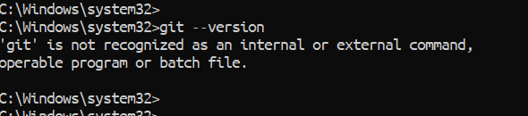

* We can see that Git is not present in Windows. To install Git, open the earlier downloaded Git for Windows “.exe” file and click Next the button.

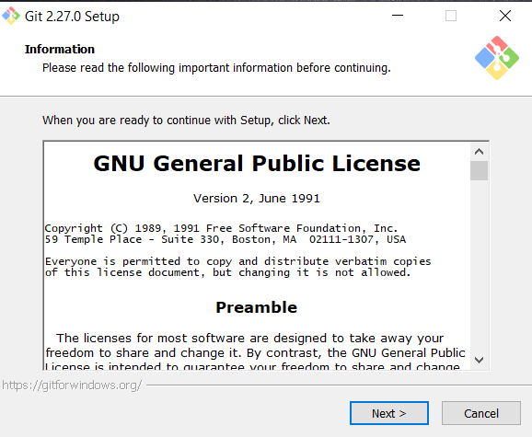

* Choose the install location and click the Next button.

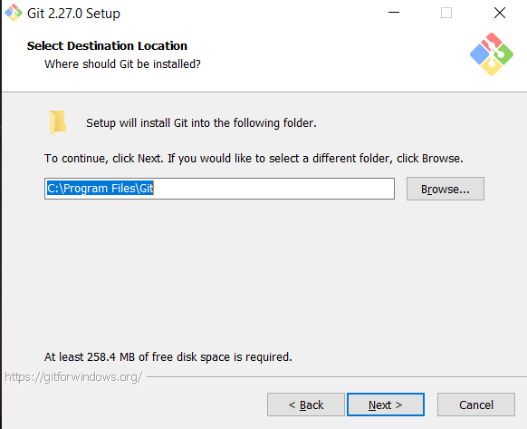

* Then select all the option in the component selection page and click the Next button. Also, you can choose the options you prefer.

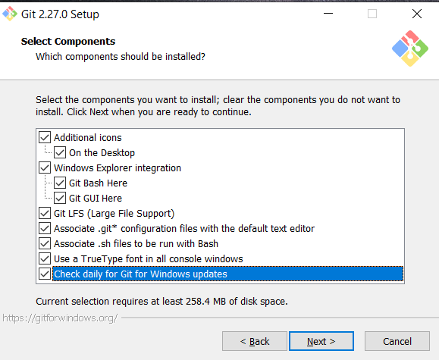

* Click the Next button on Start Menu Folder. If you do not want to create any start Menu for Git, then click on the box in down.

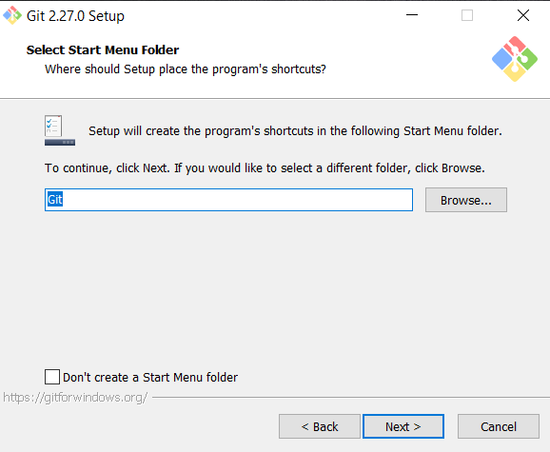

* Click the Next button on the editor page. No need to change anything, keep it as default.

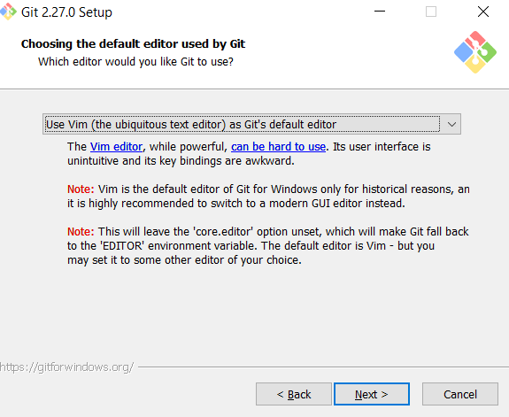

* Click the Next button on the PATH environment page.

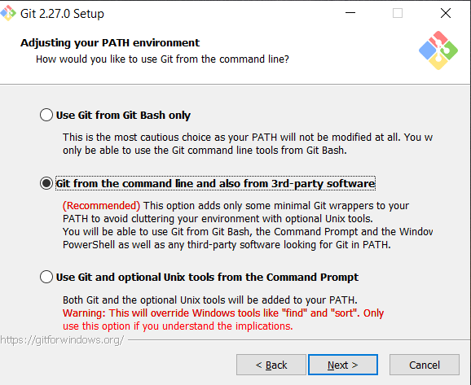

* Click the Next button on the HTTPS transport page.

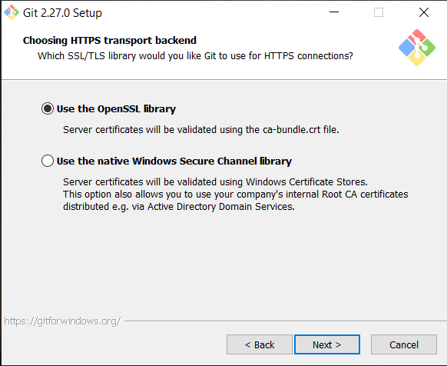

* Click the Next button on the configuration page.

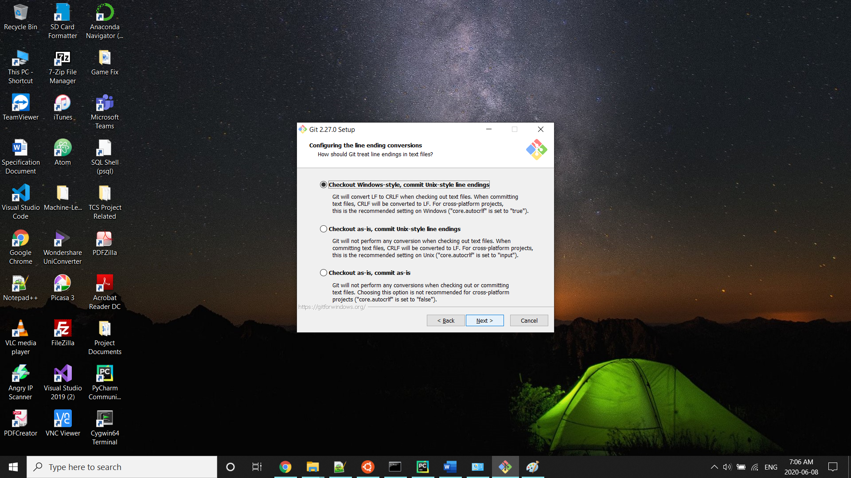

* Click the Next button on the terminal page

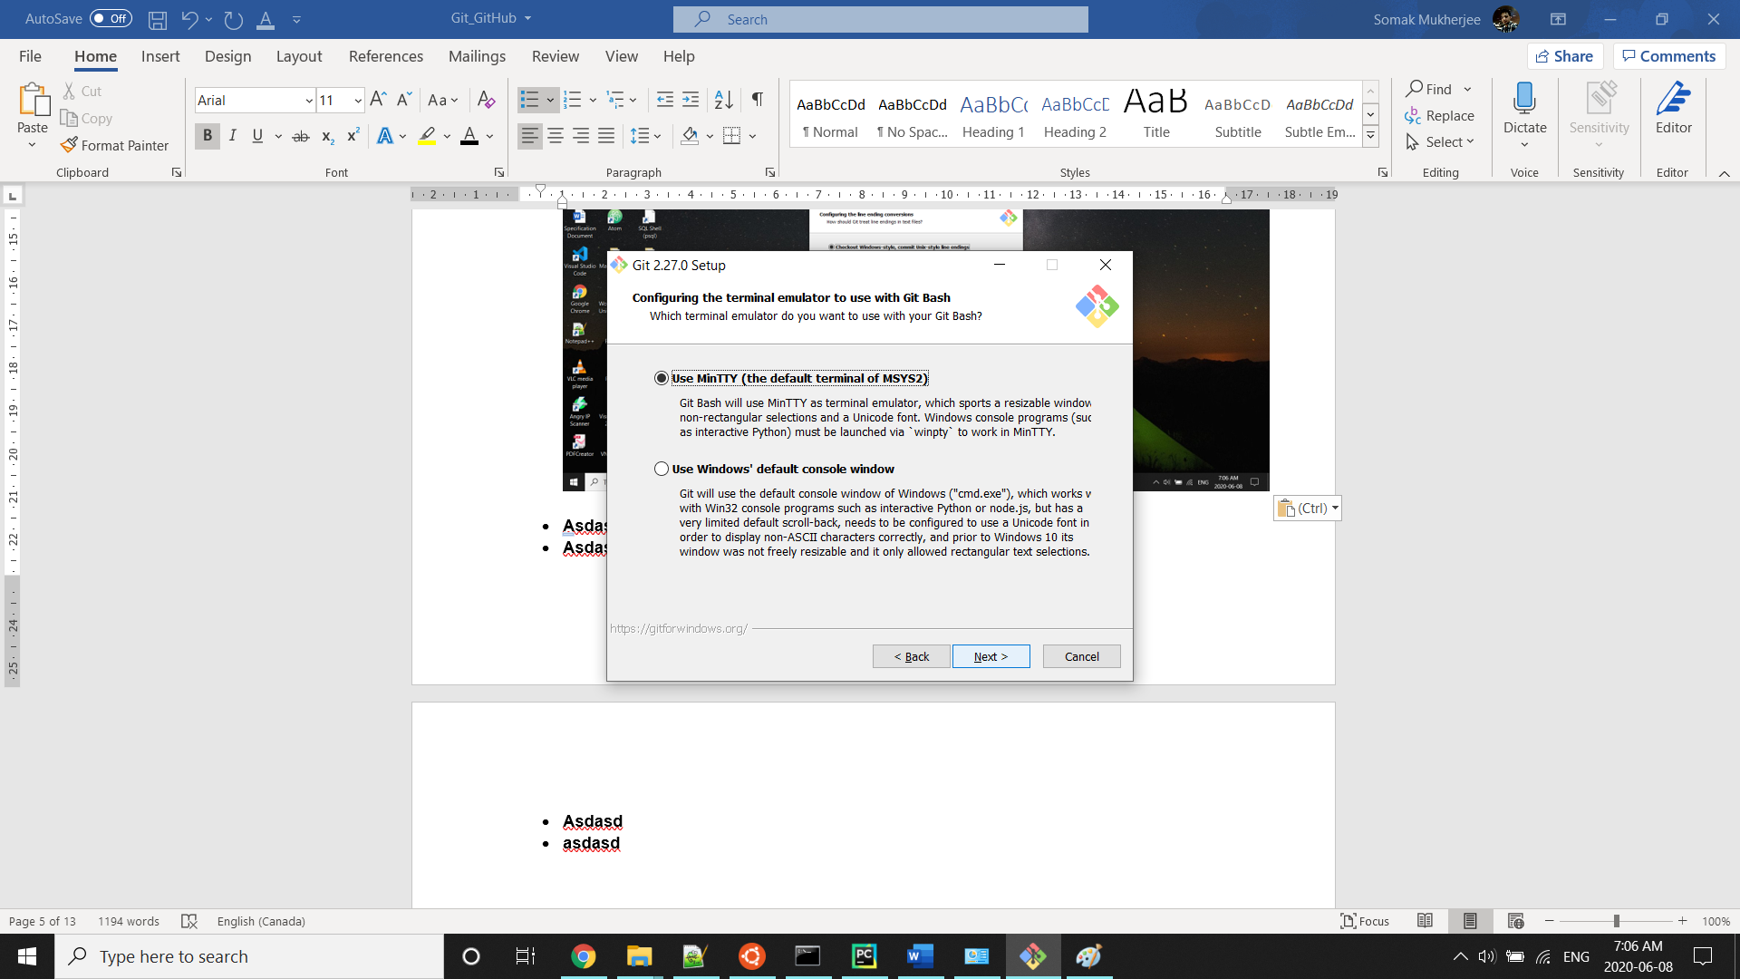

* Click the Next button on the default behavior page

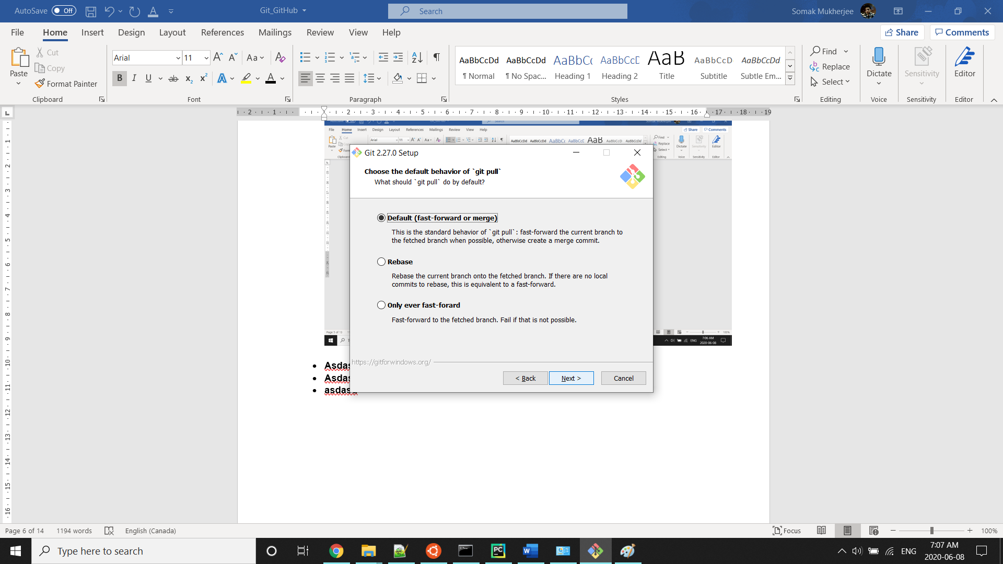

* Click the Next button on editor page

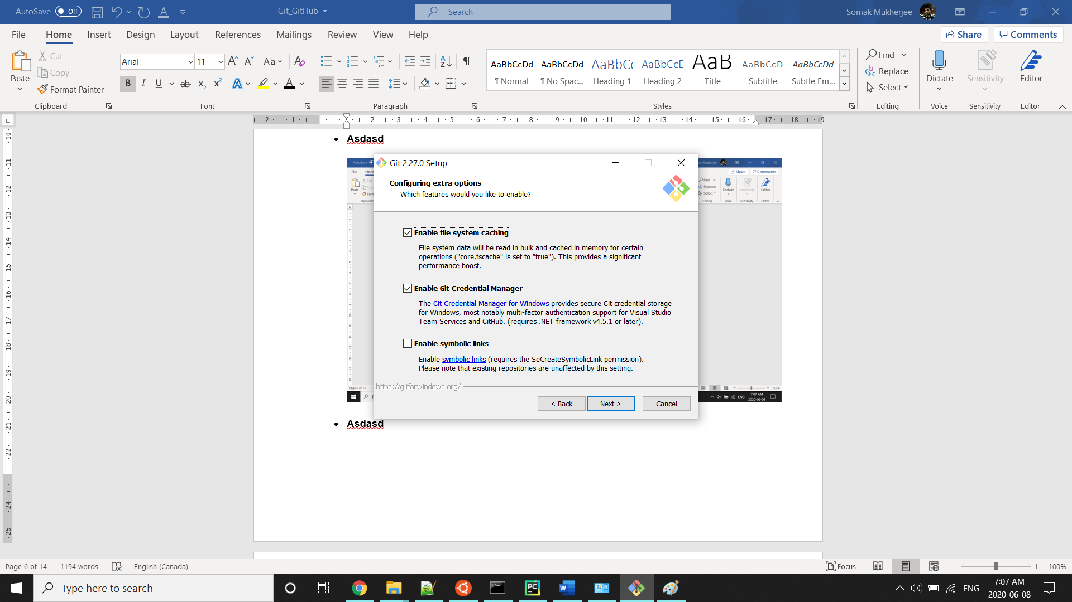

* Click the Install button on experimental option page

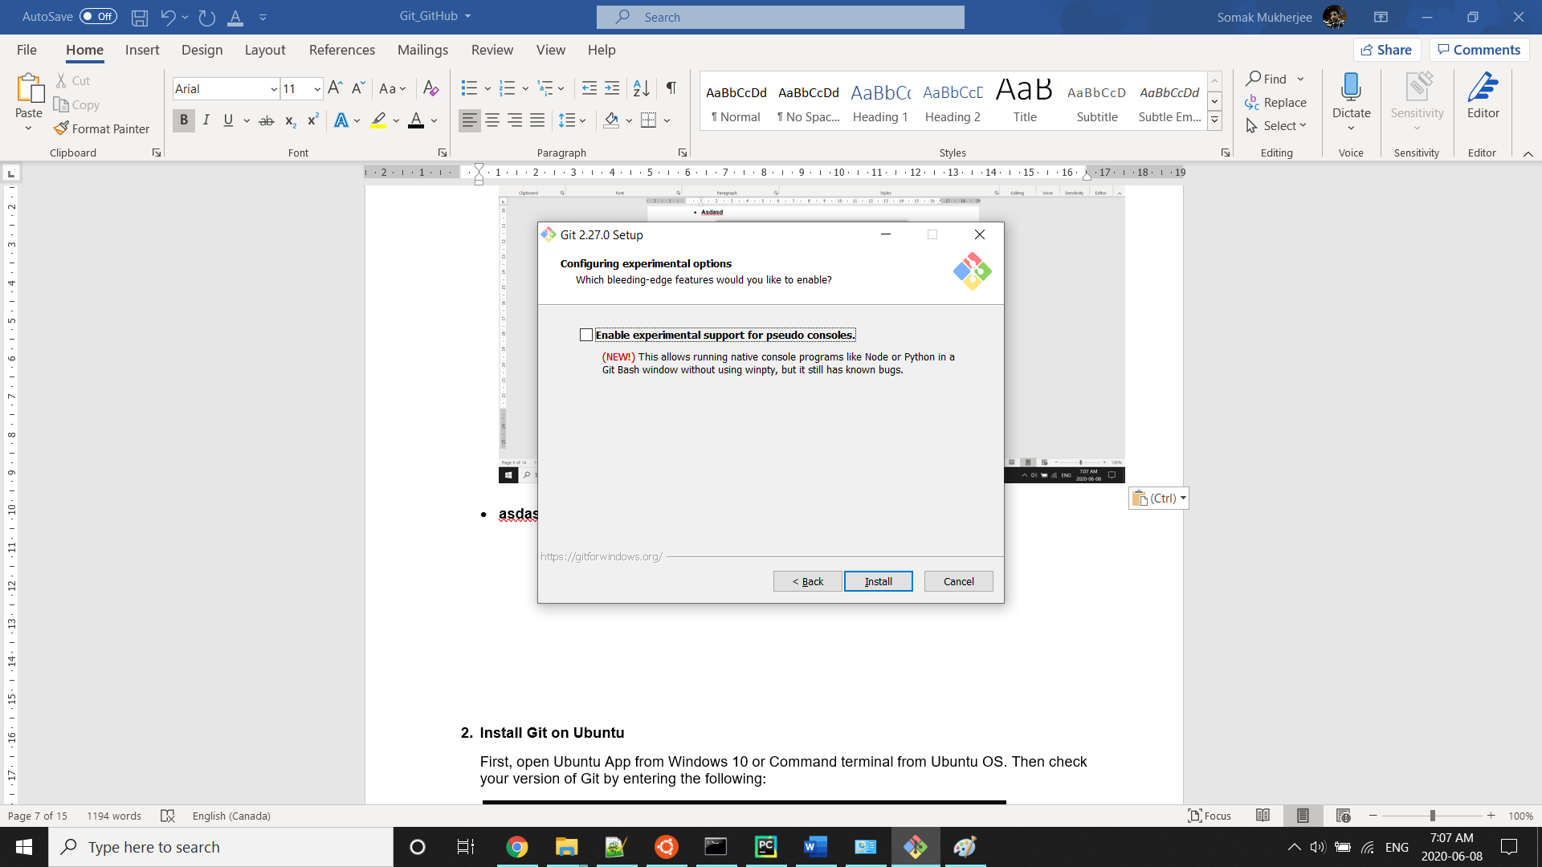

* Wait up to the installation is finished. Once it finished, you can see one Git Bash option on your desktop. It is also a Linux based bash, and here you can also do the same activities as Ubuntu.
* Now go to Command Terminal again and verify the Git Version.

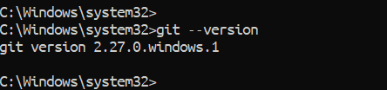

1. **Install Git on Ubuntu**

First, open Ubuntu APP from Windows 10 or Command Terminal from Ubuntu OS. Then check your version of Git by entering the following:

$ git –-version

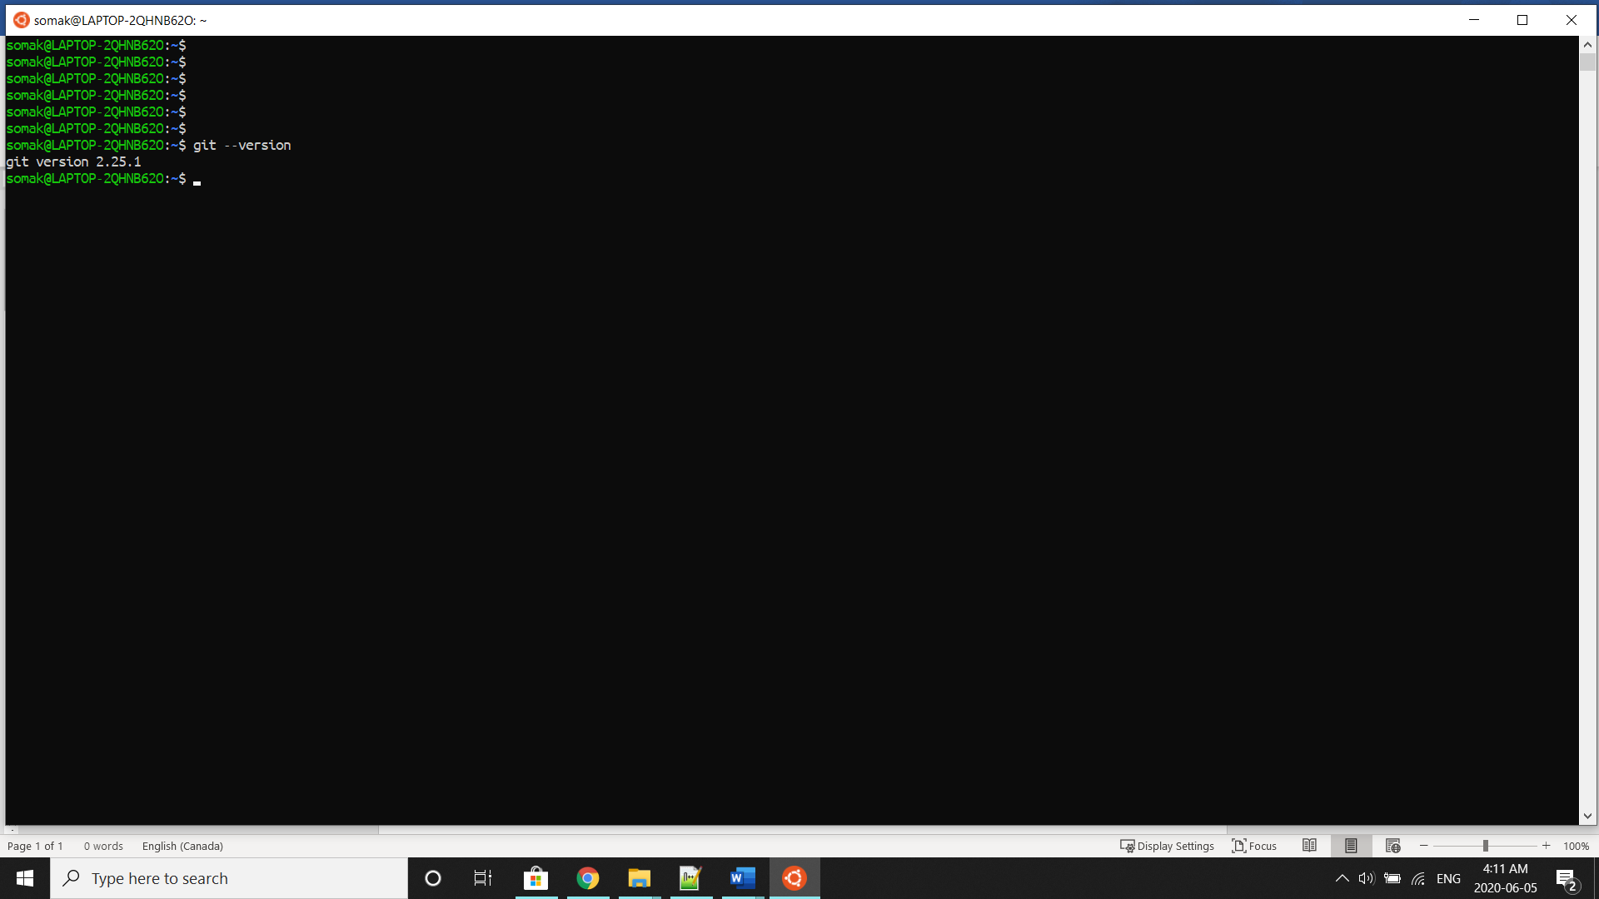

Though Git latest version comes with Ubuntu Installation, here we will show if you need to install it from scratch.

There are two way you can install Git:

1. Install Git using Command Terminal
2. Install Git using Shell Scripts
3. **Install Git using Command Terminal**

Before installing Git, we need to run update and upgrade command for Ubuntu packages. First, run the update command as follow:

$ sudo apt update

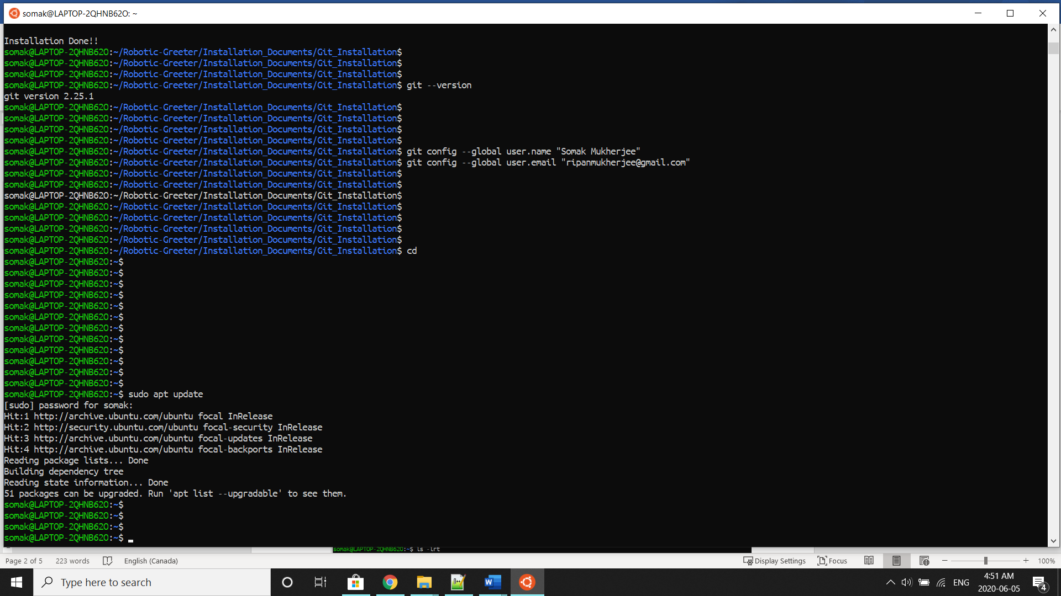

Then run the upgrade command as follow:

$ sudo apt upgrade

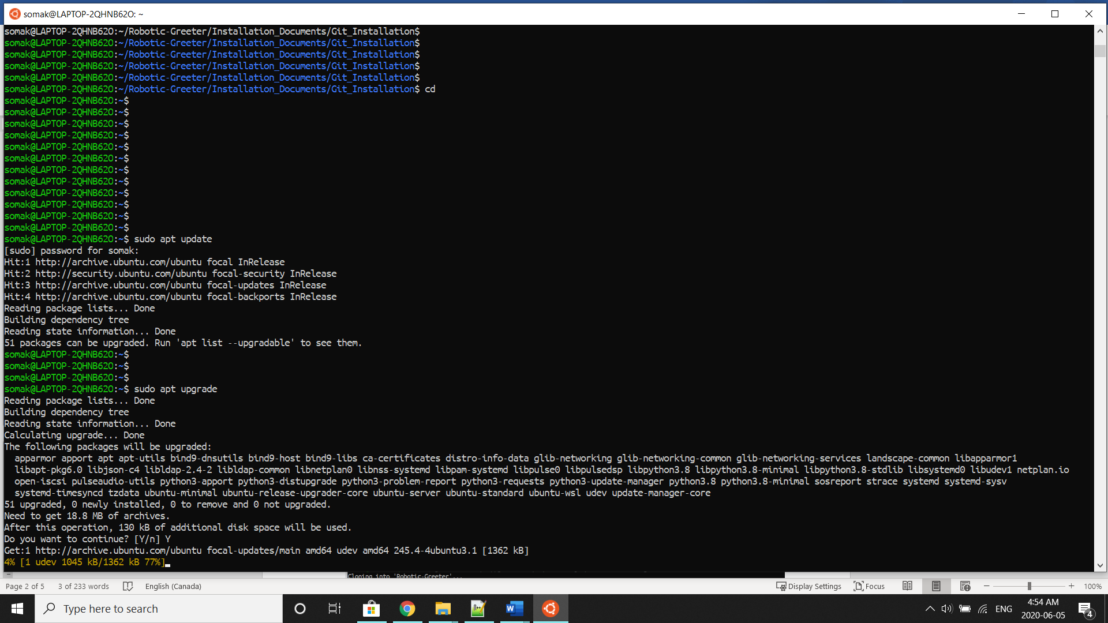

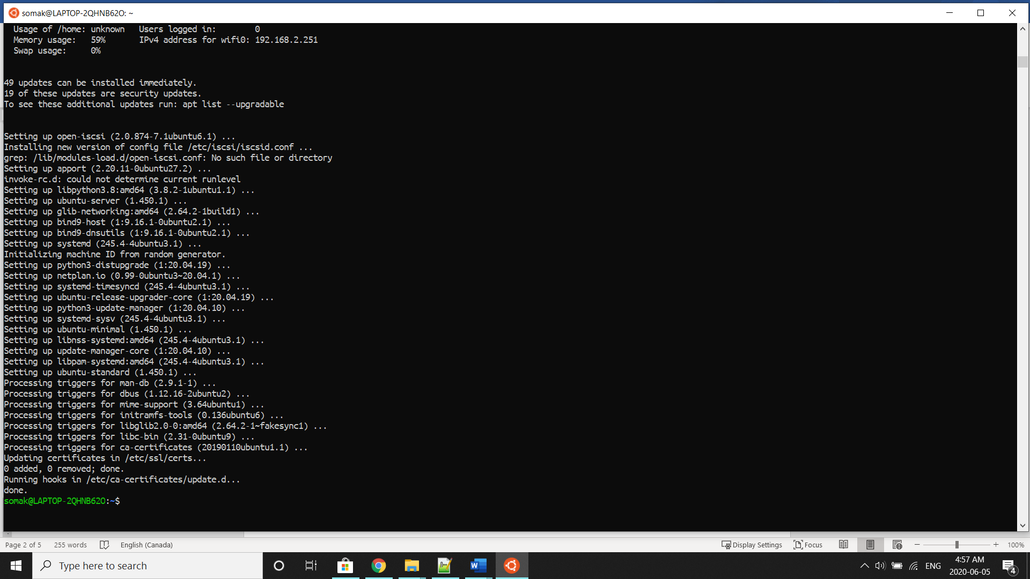

Once the upgrade is done, we will start to install Git as follow:

$ sudo apt install git

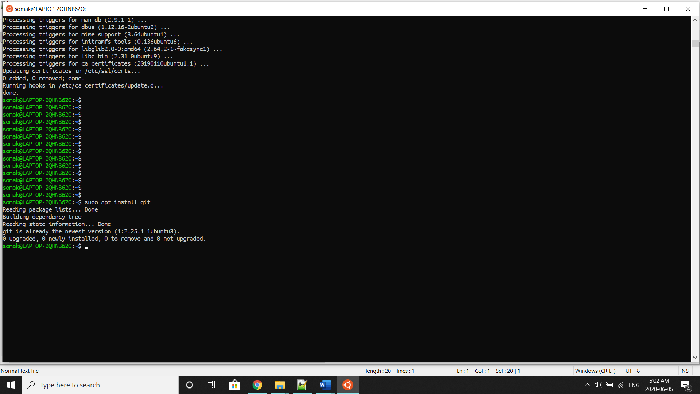

If you installed Git earlier with the latest version, you would see “git is already the newest version” message. If not, then this command will install Git for you. Later you can recheck the version.



$ git –-version

1. **Install Git using Shell Scripts**

First we need to download the Robotic-Greeter folder from the [Robotic-Greeter-GitHub](https://github.com/ripanmukherjee/Robotic-Greeter) link:

You can download it in two ways:

1. Clone it with command Terminal
2. Download it as a Zip file

Inside of the Robotic-Greeter folder, we have the shell (Unix) script, which you need to run, and this script will automatically install Git on your computer. You can keep the shell script for your future reference, and whenever you need to update the Git version, you can directly run the shell script.

1. **Using Clone method**

Go to Ubuntu APP from Windows 10 or Command Terminal from Ubuntu OS and run the following command:

$ git clone https://github.com/ripanmukherjee/Robotic-Greeter.git

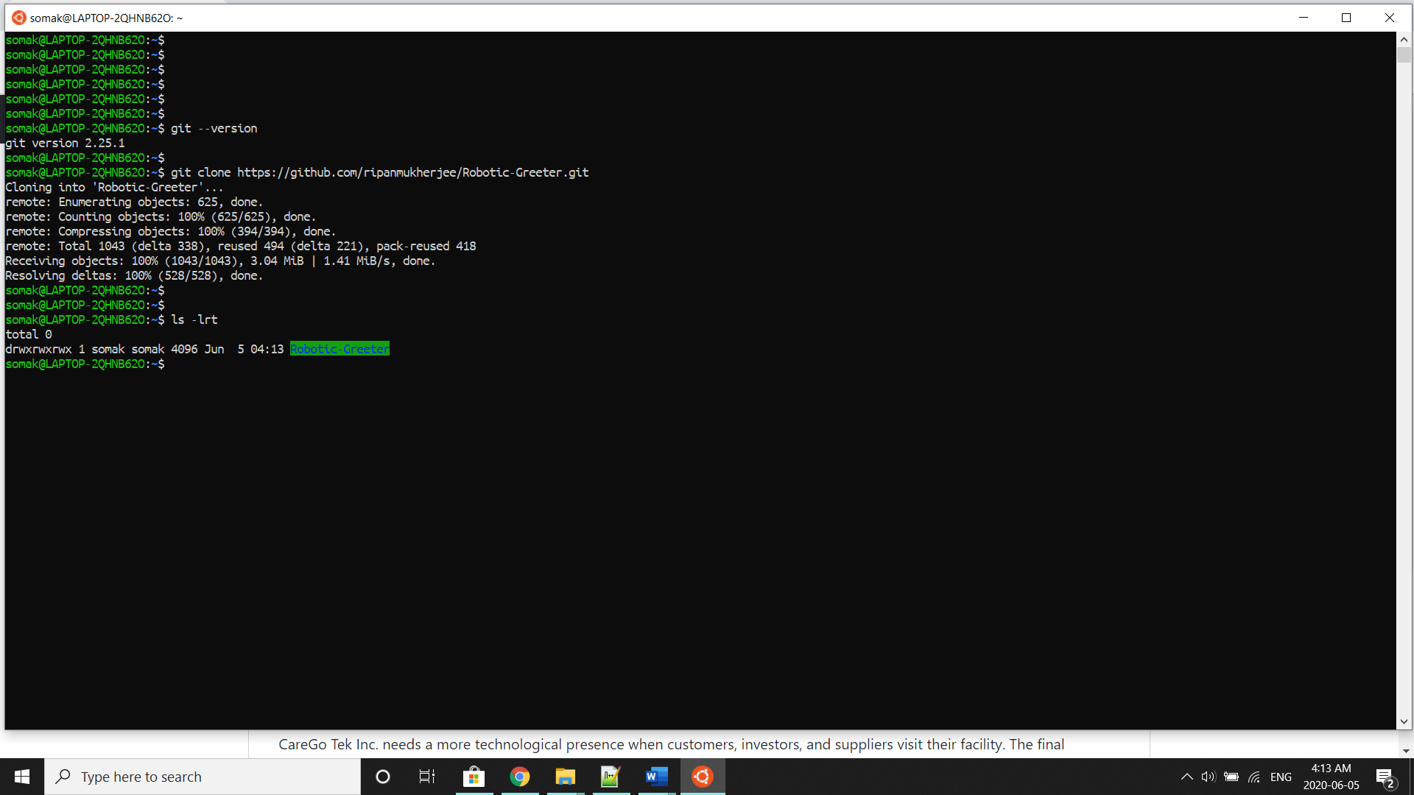

This command will automatically download the Robotic-Greeter folder on your computer.

1. **Download as Zip**

Also, you can directly download the Zip file and Unzip it. Then it would be best if you put it in the proper directory or your project directory.

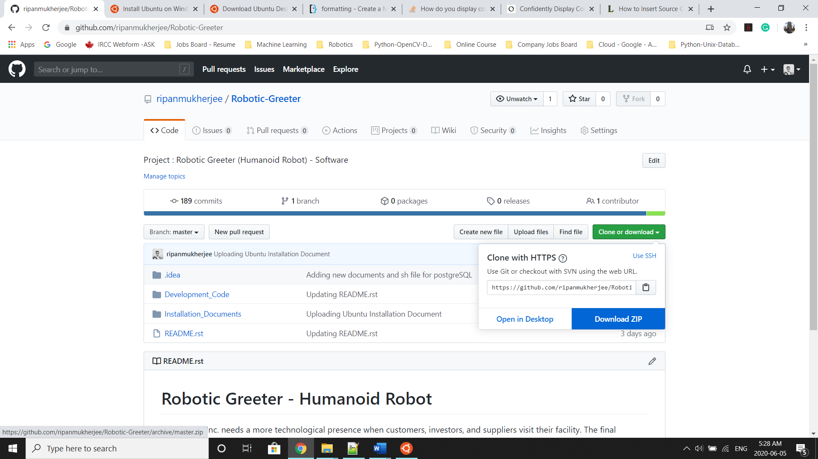

Once the download is complete, please go to the following directory:

$ cd Robotic-Greeter/Installation_Documents/ Git_GitHub_Installation

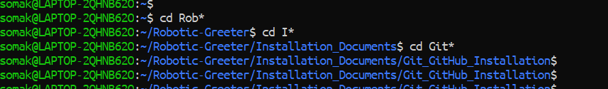

In the Git_Installation folder, you will get **Git_GitHub_Installation.sh**script. To list the directories and files in this folder run “ls -lrt” and later change the executable permission for the file with “chmod”.

$ ls -lrt

$ chmod +x *.sh

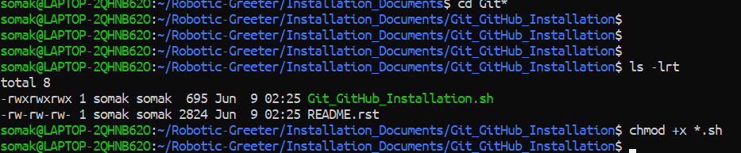

After that, run the scripts as follow:

$ sh Git_GitHub_Installation.sh

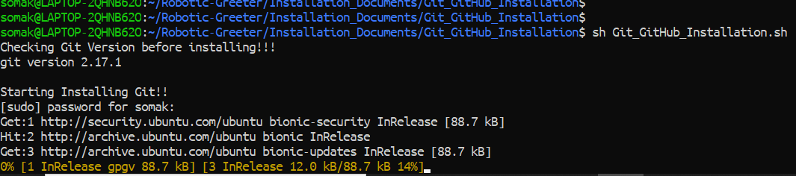

After this you can again verify it as below:



Installation done!!

After the installation is done, you need to set some parameters (configuration) for the first time.

**Working with Git & GitHub**

The first thing you should do when you install Git is to set your username and email address. This is important because every Git commit uses this information, and it is immutably baked into the commits you start creating:

$ $ git config --global user.name "Example Name"

$ $ git config --global user.email "Example@email.com"

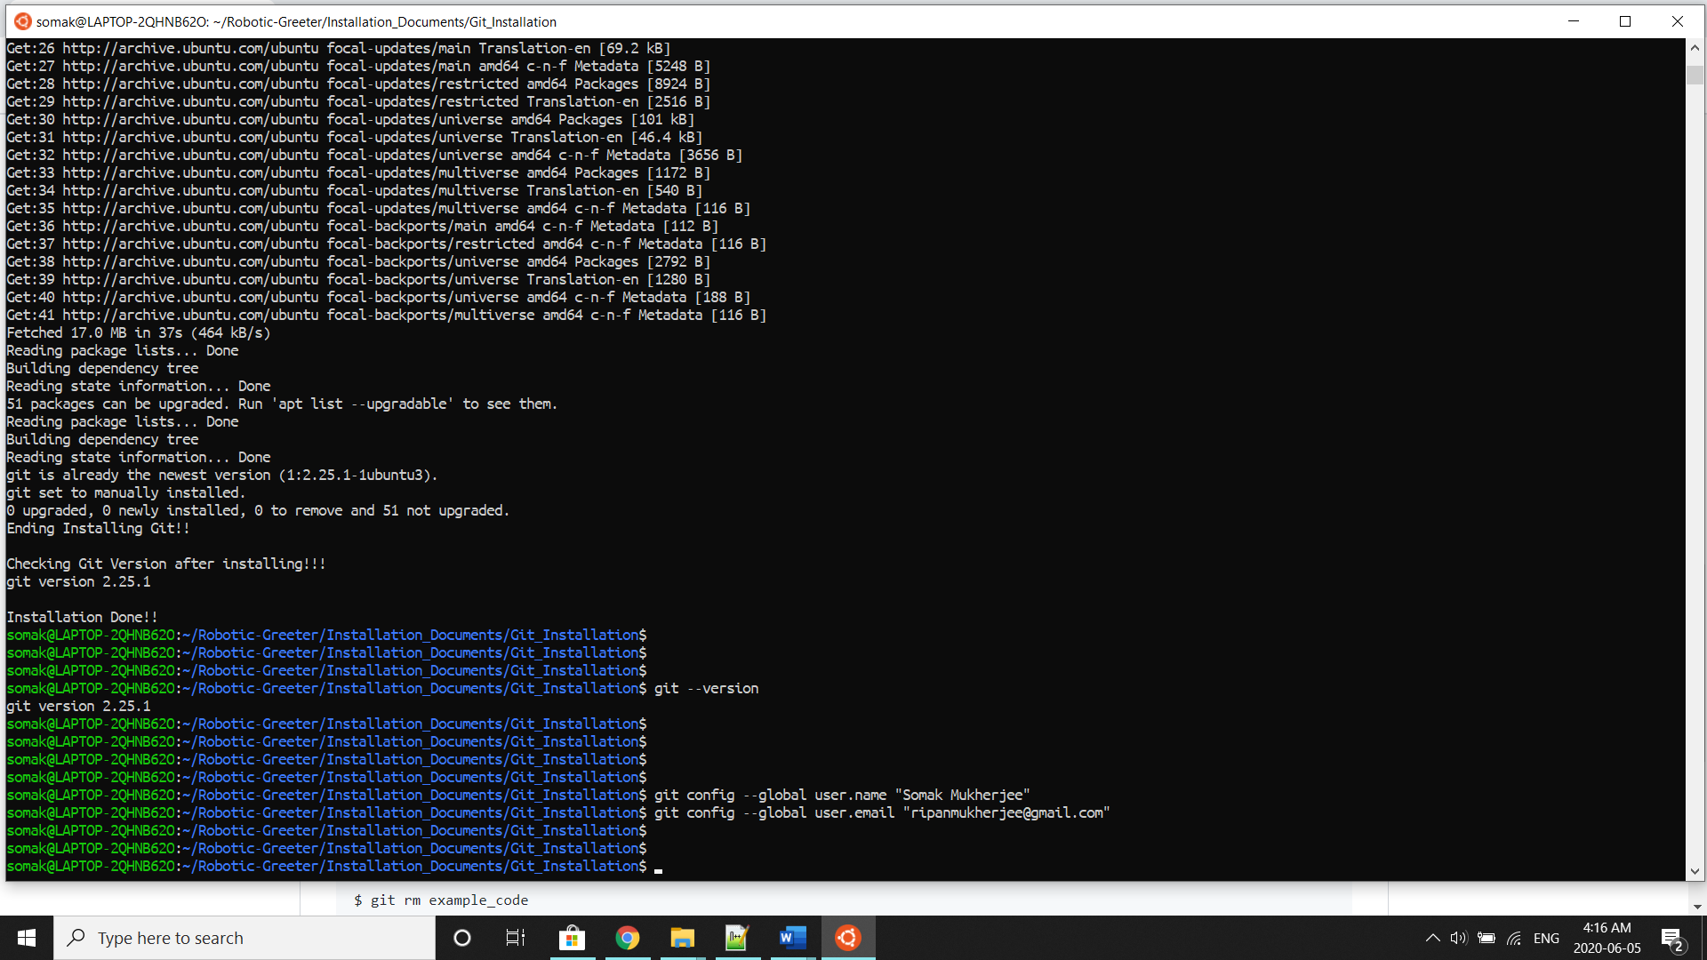

Again, you need to do this only once if you pass the **--global** option, because then Git will always use that information for anything you do on that system. If you want to override this with a different name or email address for specific projects, you can run the command without the **--global** option when you are in that project.

Now, whenever you modify or add or remove any codes or directories or files then you need to check the status, add (add), rm (remove) and commit it as follow:

$ $ git status

$ git add example_code

$ git rm example_code

$ git status

$ git commit -a -m “Comment”

$

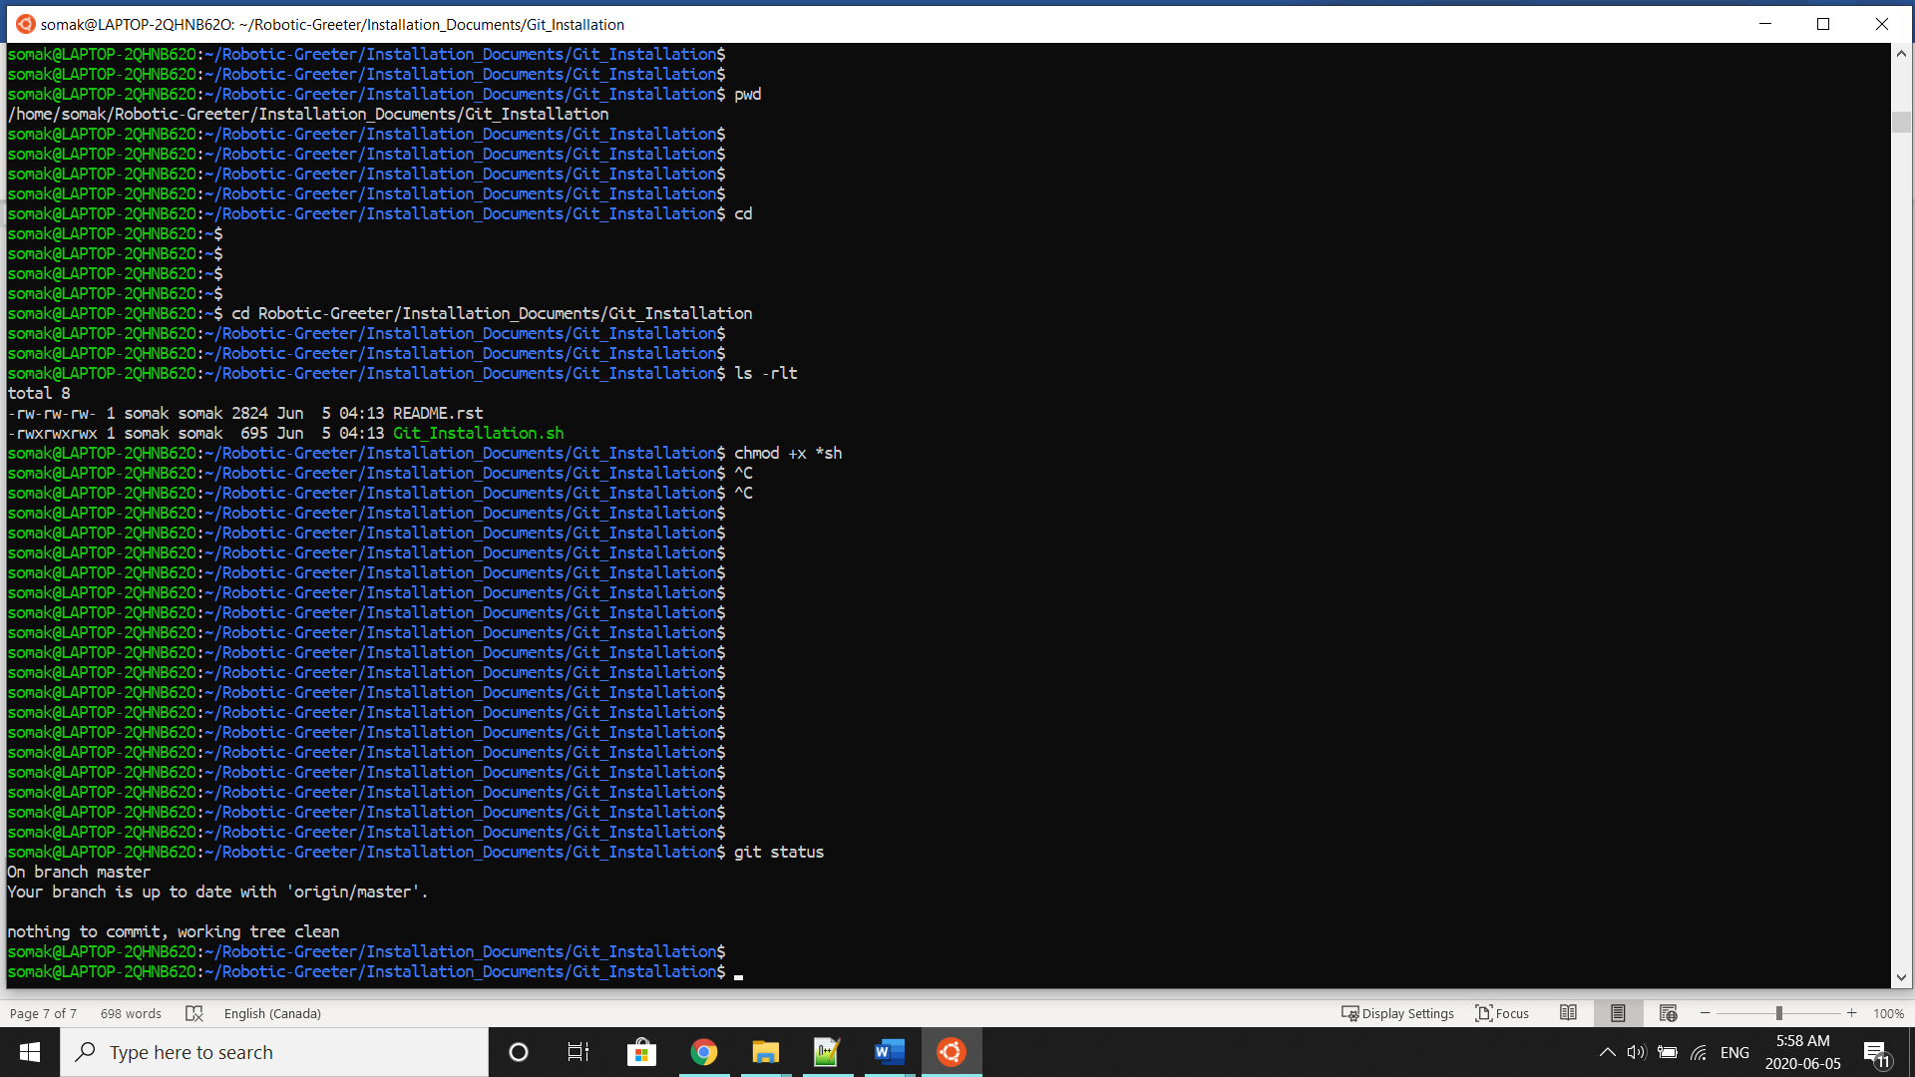

By running git status, you will get information that do you have anything to add or remove or commit in the folder. If yes, Git will show you that what you need to do if not then the status will show as “nothing to commit”

Example: if you add a temp.txt file and run the git status as follow:

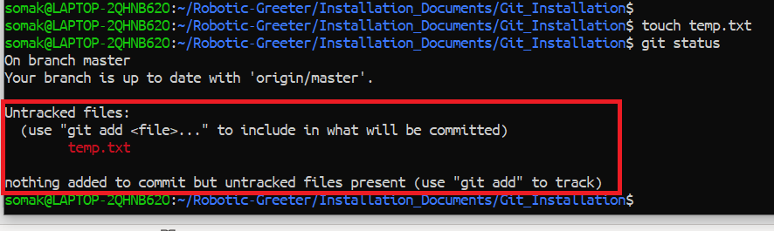

Here you can see Git is showing “Untracked file: temp.txt” and it is showing (use "git add <file>..." to include in what will be committed). So, we can understand that you need to add the file and later commit it as below:

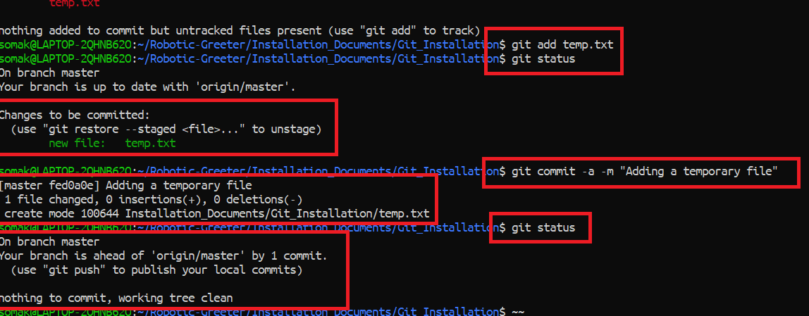

You can do the same when you remove files or directories. Also, Git gives us the option to push the new changes from your computer to the GitHub repository (Cloud repository) and pull it from the GitHub repository (Cloud repository) to your computer. But you can push only to and from your GitHub repository since the other repository could be private or password protected. Because push command will always ask for username and password of the GitHub page. You can do so as follow:

$ $ git push

$ $ git pull

For more details related to Git and GitHub, then please visit the [Git](https://git-scm.com/) website.